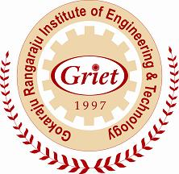 | GokarajuRangaraju Institute of Engineering and Technology (Autonomous)  Bachupally, Kukatpally, Hyderabad – 500 090, A.P., India. (040) 6686 4440
course objectives

Academic Year : 2012-2013

Semester : I

Name of the Program: B.Tech Civil Engineering Year: I Section: B

Course/Subject: English Lab Course Code: GR11A1015

Name of the Faculty: Ms.P.SujeethaRao Dept. Basic Sciences

Designation: ASST.PROFESSOR
On completion of this Subject/Course the student shall be able to:

S.No | Objectives
1 | To enable the student recognize the role and importance of language and communication skills.
2 | To equip the student with an ability to convey the identified, formulated and proposed solutions by various communication mediums.
3 | To create awareness in the student about the etiquette and the importance of the formality in communication.

Signature of HOD Signature of faculty

Date: Date:

